PERFORMANCE MANAGEMENT AND APPRAISAL
Module-4
- PERFORMANCE APPRAISALS
Definition 1: Systematic Evaluation
- “It is a systematic evaluation of an individual with respect to performance on the job and individual’s potential for development.”
- Systematic evaluation of present potential capabilities of personnel and employees by their superiors, superiors superior, or professional from outside
- It is a process of collecting, analyzing, and evaluating data relative to jobs, and results of individual
Definition 2: Formal System, Reasons and Measures of future performance
- “It is formal, structured system of measuring, evaluating job related behaviors and outcomes to discover reasons of performance and how to perform effectively in future so that employee, organization and society all benefits.”
- Performance management
- Performance management is defined as a continuous process of identifying, measuring, managing, and developing the performance of individuals and groups in an organization.
- Performance appraisal
- Performance appraisal is the ongoing process of reviews of employee performance over time, and is one component of the entire performance management process. It is a formal system, which requires a manager to carry out this activity in a continuous manner.
Meaning of Performance Appraisals
- Performance Appraisals is the assessment of individual’s performance in a systematic way. It is a developmental tool used for all round development of the employee and the organization.
- Assessment should be confined to past as well as potential performance also. The second definition is more focused on behaviors as a part of assessment because behaviors do affect job results.
- Objectives of Performance Management
Objective for the Employee
- Personal development
- Work satisfaction
- Engagement in the organization
Objective for the organization:
- Provide information about employees and their development
- Measure the efficiency with which human resources are being used and improved
- Provide linkages to compensation and rewards to employees
- Maintain organizational control
- Performance Management and Performance Appraisal
Performance Appraisal | Performance Management
Focus is on performance appraisal and generation of ratings. | Focus is on performance management.
Emphasis is on relative evaluation of individuals. | Emphasis is on performance improvements of individual officer and his departmental or team performance.
Annual exercise⎯though normally periodic evaluations are continuous process with quarterly or periodic performance made. | Continuous process with quarterly or periodic performance made review discussions.
Emphasis is on ratings and evaluation. | Emphasis is on performance planning, analysis, review,  development and improvements.
Rewards and recognition of good performance is an important component. | - Performance rewarding may or may not be an integral part  - Defining and setting performance standards is an integral part.

Performance Appraisal | Performance Management
Designed and monitored by the personnel/administration department. | Designed by the personnel/HR department but could be monitored by the respective depart ents themselves.
Ownership is mostly with the administration/personnel. | Ownership is with line managers; personnel/administration facilitates its implementation.
KPAs and KRAs are used for bringing in objectivity. | KPAs or KRAs are used as planning mechanisms
Developmental needs are identified at the end of the year on the basis of the appraisal of competency gaps. | Developmental needs are identified in the beginning of the year on the basis of the competency requirements for the coming year.
There are review mechanisms to ensure objectivity in ratings. | There are review mechanisms essentially to bring performance  Improvements.
It is a system with deadlines, meetings, input, and a format and output. | It is a system with deadlines, meetings, input, output, and a format.
Format-driven with emphasis on those Linked to promotions, rewards, training and development interventions, placements, etc. | Process driven with emphasis on the format as an aid Linked to performance improvements and through them to other career decisions as and when necessary.

- Common Problems with Performance Appraisals
- Performance appraisal and total quality management.
- The second set of problems with the system of performance appraisals is that it is often a flawed process. The common flaws are as follows:
- Inaccurate
- Infrequent
- Comparison with peers
- Unsuitable for the millennials
The performance Management process
- Establish performance standards.
- Communicate the standards.
- Measure actual performance.
- Compare actual performance with standards and discuss the appraisal.
- Taking corrective action if necessary.
- Establish and communicate expectations for performance.
- Observe and measure individual performance against standards.
- Reinforce performance to provide remedies.
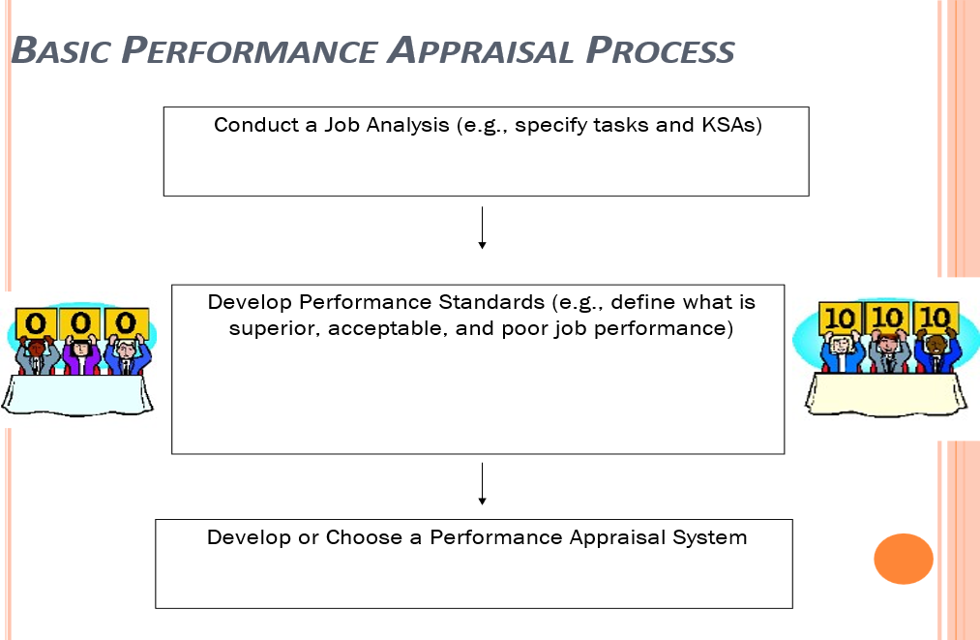
- Basic Performance Appraisal Process

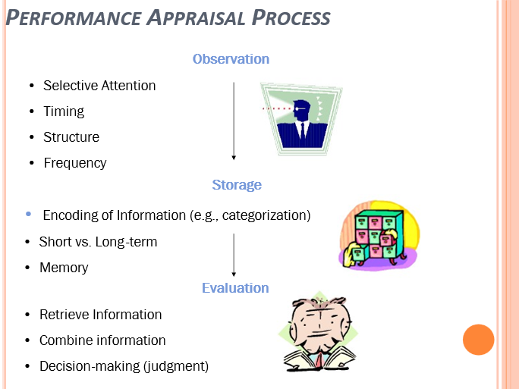
Performance Management Process
The circular process consists of six interconnected stages :
- Contextual preparation
- Planning
- Execution
- Assessment
- Review
- Renewal of performance.
Step 1: Contextual information (also Described as Pre-requisites)
- The performance management process, in order to take off successfully in an organization, requires two key prerequisites.
- It presupposes that the organization would have clarified its organizational vision, mission and strategy planning.
- A mastery over the requirements of the jobs, and more specifically, clear definition of the roles for performing a given job within the organizational framework is the second prerequisite.
- The pre-requisite stage also covers one more important element: the commitment and support of the senior leadership and top management. The support is manifested through various steps, which include:
- Challenging work for star performers
- Healthy investment in learning and development projects
- Appropriate structure for dealing with poor performance
- Reward and recognition aligned to PMS.
Step 2: Planning
- The goals of the performance planning are:
- To build agreement on the employee’s job responsibilities.
- To clear doubts about targets and objectives that needs to be achieved.
- To bring into focus the competencies relevant for the job.
- To develop a career development plan for the employee.
- Performance plan has the following elements:
- Key Accountabilities⎯they are broad areas of a job for which the employee is responsible for producing results.
- Specific Objectives⎯they are statements of outcomes a model way to develop outcomes is by using the acronym SMART. SMART stands for specific, measurable, attainable, realistic, and timely.
- Performance Standards⎯the performance standards/criteria used in organizations are as diverse as traits, behaviors, competencies, goal achievement, and potential to improve.
Step 3: Performance Execution
- Performance execution is the joint responsibility for both the employee and the manager.
- Employee responsibility:
- Committing to goal achievement
- Seek performance feedback
- Effective and periodical communication with manager
- Collection and sharing of information on performance
- Active participation in performance reviews
- Manager responsibility:
- Creating suitable work environment to motivate the employee
- Timely documentation of performance
- Updatation of initial goals
- Feedback and coaching
Stage 4: Performance Assessment
- Using multiple sources (peers, customers, and subordinates) improves the ownership of the employee and also opens up wider area of information.
- Rater problems
- Problems with standards of evaluation: perceptual divergence in the use of words (e.g. good, adequate, satisfactory) among multiple evaluators.
- Halo effect: assigning values on the basis of an overall impression of the rate, created by a positive first impression.
- Leniency or harshness: seeing everything good, or everything bad in a rate.
- Central tendency error: avoiding use of high or low ratings, rather rate all employees on an average basis.
- ‘Recency of events’ error: rating an employee more on the basis of recent past behaviour (e.g., last five weeks) rather than overall performance
- Contracts effects: raters let another employee’s performance influence the ratings.
- Personal bias (stereotyping, similar to me): rating an employee on the basis of sex, race, and favouritism.
- The Choice of Raters
Table Showing a Comparative Efficacy of Different Rater Systems

Rater | Advantages | Disadvantages | Remedies
1.The immediate supervisor | The supervisor is the most natural choice as he is the one most likely to know what the employee should be doing. | - The supervisor may not be in regular contact. In modern organizations with virtual teams, Internet-linked offices, telecommuting, and complexity of tasks, the supervisor may not be familiar either with the employee in person or his tasks.  - Personal bias might hinder objective evaluation. | Use multiple evaluators, including the supervisor to improve the objectivity quotient.
2. Peers | 1. Often know the job of the employee more closely than the supervisor and are more directly affected by the employee’s actions.  2.In a Team environment , peers can accurately assess the interpersonal competencies of the employee. | - Possibilities of a different kind of bias. Ego conflicts and personal biases can colour perceptions of individual employees in respect of their peers. | - Can be suitably moderated by the manager based on observed patterns.  - Possibilities for personality conflicts/bias notwithstanding, peer evaluations can provide clear insight into the inner functioning of a team, especially when the supervisor has infrequent interaction with the team.

Rater | Advantages | Disadvantages | Remedies
1.The immediate supervisor | The supervisor is the most natural choice as he is the one most likely to know what the employee should be doing. | - The supervisor may not be in regular contact. In modern organizations with virtual teams, Internet-linked offices, telecommuting, and complexity of tasks, the supervisor may not be familiar either with the employee in person or his tasks.  - Personal bias might hinder objective evaluation. | Use multiple evaluators, including the supervisor to improve the objectivity quotient.
2. Peers | - Often know the job of the employee more closely than the supervisor and are more directly affected by the employee’s actions.  - In a Team environment , peers can accurately assess the interpersonal competencies of the employee. | - Possibilities of a different kind of bias. Ego conflicts and personal biases can colour perceptions of individual employees in respect of their peers. | - Can be suitably moderated by the manager based on observed patterns.  - Possibilities for personality conflicts/bias notwithstanding, peer evaluations can provide clear insight into the inner functioning of a team, especially when the supervisor has infrequent interaction with the team.

Stage Five: Performance Review
- At the review meeting the employee and manager discuss the ‘what’ and the ‘how’ of results achieved against performance plans.
- The manager and employee should discuss:
- Commitments, if any, from the last review meeting.
- Specific achievements since the last conversation.
- Difficulties hampering performance, the reasons and the ways and means of overcoming them, including use of skills in past achievements.
- The implications of changing behaviors.
- Action plan for future.
Stage Six: Renewal
- In the last phase, the manager uses insights and learning from the last cycle to more effectively plan performance in the next cycle.
- The manager and employee review and make appropriate adjustment of goals in tune with the organization’s mission, vision, values, and strategy. This could lead to setting new objectives and standards, new accountabilities , development of new competencies for the upcoming performance period; and creating the ongoing and continuous nature of the performance management cycle.
- The Critical Success Factors for Performance Management System
- Strong commitment from the top management
- Alignment with strategy
- Alignment with other HR systems
- Acceptance by all levels of employees
- Adequate organizational training
- Automation
- Types of Performance Rating Systems
The performance rating systems can be classified into two broad groups:
- Relative- ranking ordering,
- paired comparisons
- forced ranking.
- Absolute⎯narrative method or essays,
3. behaviour anchored rating scales,
4.critical incidents,
5.graphic rating scales,
6.management by objectives.
- Rank Ordering
- There are two methods:
- Simple⎯the rater orders all rates , from lowest to highest.
- Alternation⎯also referred to as multi-person comparison methods, each employee’s performance is matched with that of her peers, eventually producing a rank order from top to bottom.
- Paired Comparison
- It is a method of evaluation in which each employee is compared with each other employee. Scores derived from paired comparison are often compared with the standard deviation and mean of all scores to arrive at standard scores for future comparisons.
- In this method, the number of pairs of rates to be compared may be calculated from the formula n (n-1)/2, n denoting the number of employees.
Example, if a firm has just 10 employees , all 10 individuals will be compared in this process , (10(9))/2 , requiring 45 comparisons .
- The rater’s task is simply to choose the better of each pair and each individual’s rank is determined by counting the number of times he or she was rated superior.
- Forced Ranking
- It is also known as vitality curve, rank and yank and forced distribution.
- The forced ranking system is based on the much debated assumption that ratees confirm to a pattern of normal distribution.
- One of the criticism of forced ranking system is that the system may introduce a great deal of error, if a group of ratees do not confirm to the usual distribution and may ,as a group, be either superior or substandard.
- In short, rather than eliminating error, forced distribution may introduce another kind of error.
- It may lead to unintended negative effects on employee morale, teamwork and collaboration, thus affecting shareholder perceptions.
- The Narrative or the Essay Method
- One of the simplest among absolute ratings, a rater is required to write a description of the ratee’s performance, his strengths, weaknesses and areas of improvement.
- The narrative structure provides the rater with the opportunity to make their evaluative assessment form that can go beyond a mere ticking of a box.
- The underlying belief is that a rater who is conversant with the rate and his work can produce a narration which can be as powerful as acceptable as a formal appraisal system. Narratives can be used alone, or combined with another method or form.
- The positives of a properly executive Narrative rating include scope for detailed feedback.
- The difficulties with this form are: sans quantitative information, comparisons between individual employees, groups or teams become virtually impossible.
- Critical Incidents Method
- The ’critical incident method’ is a set of procedures used for collecting direct observations of employee behavior which have critical significance and meet methodically defined criteria.
- Critical incidents refer to reports prepared by knowledgeable observers of specific employee behaviors that focus on either particularly outstanding behaviors or particularly questionable behaviors. Supervisors document critical incidents as they occur usually in a file folder (kept for each employee, either a hard copy or an electronic one).
- Advantages⎯they provide rich source of data, represent the employee’s perspectives adequately, and can capture rare incidents which may not be captured in any other formal method. The supervisors can concentrate on actual behaviour on job, rather than exercising one’s mind about abstract traits, and use them to provide meaningful feedback to the rates.
- Disadvantages⎯excessive reliance on memory, requirement of accurate and truthful reporting of them, a bias for recent events, and difficulty experienced by employees in telling a complete story in necessary details. The supervisors may resend the workload arising out of meticulous process of documentation, and give it low priority, as a consequence of which the feedback
- Graphic Rating Scales
- The ratees get evaluated on a continuum with anchor points that demarcate levels of effectiveness. For each ratee, the level of effectiveness is indicated at specific points on the continuum. The scale typically features a Likert scale.
- The number of points on the rating scale can vary from 1-3, 1-5, or 1-9 with the maximum end point of 5 to 9 being considered suitable to yield the highest quality of ratings on the basis of research.
- Advantages⎯adaptability to a diverse variety of formats, user friendly, easy to construct, have quick process and have face validity.
- Graphic rating scales can be differentiated based on the type and amount of information presented in the anchors. The common formats include fuzzy adjectives (e.g., ‘marginal’, ‘average’, or ‘outstanding’ or ‘Poor’, ‘Average’, and ‘Excellent’) as anchors.
- Table A Factor in a ‘graphic rating scale’
- HCareless worker. Tends to repeat some types of errors
- Work is sometimes unsatisfactory because of errors or untidiness.
- Usually turns out acceptable work. Not many errors.
- Checks and observes his work. Can be relied upon.
- Work is of highest quality. Errors extremely rare, if any. Little wasted effort.
Comments _________________________________________________
- ow would you rate this employee in respect to the quality of work he turns out , the neatness and accuracy evident in the job he does?

- Behaviorally Anchored Rating Scales
- BARS comprises five to ten vertical scales, depending on the nature of the job under review. Each scale describes a key performance dimension of the job. Each dimension is typically depicted by five or more critical incidents corresponding to ‘highly effective’ to ‘highly ineffective’ visible job behaviours on the job dimension.
- Disadvantages⎯inter-rater reliability and rater errors (due to multiple developmental processes and formats) and high cost associated with the employee time and effort required to develop and use the instrument.
- Sample Behaviorally Anchored Rating Scale for Sales Performance by Sales Trainee
- MBO
- MBO implies a management approach by which employees participate in a vertically cascading process of setting objectives, covering production, costs, sales and profits, together with their superiors.
- The goals set in the participative manner become the basis of subsequent periodical evaluation and rewards.
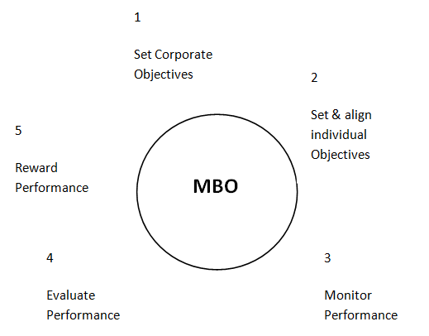

- Balanced Scorecard
- It is a strategic performance management tool that can be used by managers to keep track of the execution of activities by the staff within their control and to monitor the consequences arising from these actions. It talks about four domains of performance:
- Financial: measures which answer the question "How do we look to shareholders?" Examples: cash flow, sales growth, operating income, return on equity.[
- Customer: measures that answer the question "How do customers see us?" Examples: percent of sales from new products, on time delivery, share of important customers’ purchases, ranking by important customers.
- Internal business processes: measures that answer the question "What must we excel at?" Examples: cycle time, unit cost, yield, new product introductions.
- Learning and growth: measures that answer the question "How can we continue to improve, create value and innovate?” Examples: time to develop new generation of products, life cycle to product maturity, time to market versus competition.

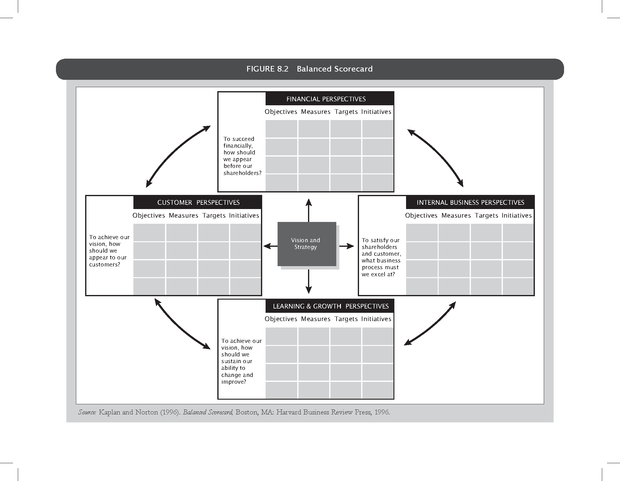
- Future of Performance Management
- Performance Management system, like all HR processes have witnessed disruptions.
- The most debated component of PMS seems to be the used of forced ranking or Bell curve.
- The annual 'performance management' process has yielded place to a new 'performance achievement' system.
- The focus is on real-time, forward-looking conversations about setting priorities, growing strengths and creating rewarding career opportunities for employees.
- With a holistic view of performance management, the future process will foster achievements and talents of each employee with the help of leaders, who will spend more time coaching and talking with employees.
- Methods of performance appraisal
- INDIVIDUAL EVALUATION METHODS
- 1. Confidential reports
- 2. Essay evaluation
- 3. Critical incident
- 4. Checklists
- 5. Graphic rating scale
- 6. Behaviorally Anchored Rating Scales
- 7. Forced choice method
- 8. MBO
- MULTIPLE REASON EVALTUION METHOD
- 9. Ranking
- 10. Paired comparison
- 11. Forced distribution

- OTHER METHODS
- 11. Group appraisal
- 12. HRA
- 13. Assessment centre
- 14. Field review
- Methods of performance appraisal
- TRADITIONAL METHODS
- 1. Graphic rating scale
- 2. Ranking method
- 3. Paired comparison method
- 4. Forced distribution method
- 5. Checklist method
- Simple
- Weighted
- Critical incident method
- 6. Essay appraisal
- 7. Group appraisal
- 8. Confident reports
- MODERN METHODS
- 9. B.A.R.S
- 10. Assessment centre
- 11. H.R accounting
- 12. MOB
- 13. Psychological appraisal
Confidential report
- Government organization
- Descriptive report prepared at the end of every year by the employees immediate superior
- Strengths and weaknesses of the subordinates
- Impression of superior is recorded, no feedback
- Confusions of appraisee
Essay Technique
- Describe in detail the quantity and quality of the employee’s performance during the past twelve months.
- Describe the employee’s strength and weakness.
- How do you describe the employee’s potential within the company?
- What leadership skills does the employee bring to the job?
- What future development activities do you recommend for the employee?

Critical incident technique
- Manager prepares list of statements of every effective and ineffective behavior of an employee
- These critical incidents represents outstanding or poor behavior of employees on the job
- Logs are maintained
- Objective basis for conducting a thorough discussion of an employee
Checklists and weighted checklists
- A set of objectives or descriptive statements about the employee and his behavior
- If the rater believes strongly that the employee possesses a particular listed trait he checks the item or leaves it blank
- Variation to checklist is weighted list
- Expensive and time consuming
Graphic Rating Scale
- Graphic Rating Scale: A performance appraisal that rates the degree to which the employee has achieved various characteristics.
  - The graphic rating scale is the most common type of appraisal used.
  - Various characteristics such as job knowledge or punctuality are rated by the degree of achievement.
    - The rate usually receives a score of 1 to 5, with 5 representing excellent performance.
    - Some forms allow for additional comments.
Paired-comparison Approach
- A performance appraisal that measures the relative performance of employees in a group.
  - This is a method of performance evaluation that results in a rank ordering of employees to come up with a best employee.
  - This type of approach measures the relative performance of employees in a group.
Behaviorally anchored rating scales
- Behavioral expectation scale-latest innovation in performance appraisal
- It is a combination of rating scale and critical incident techniques of employees performance evaluation
- The CI serve as anchor statements on a scale and the rating form usually contains six to eight specifically defined performance dimensions
- Collect CI
- Identify performance dimensions
- Reclassification of incidents
- Assigning scale values to the incidents
- Producing the final instruemen
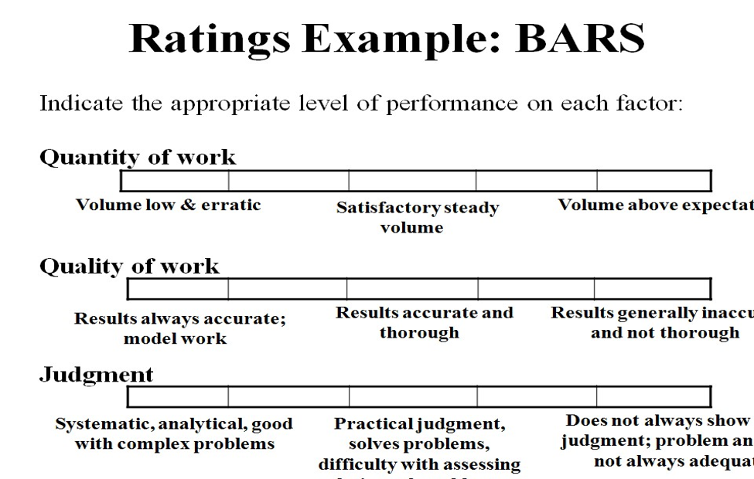
Forced choice method
- To eliminate bias and the preponderance of high ratings that might occur in some organizations.
- The primary purpose of the forced choice method is to correct the tendency of a rater to give consistently high or low ratings to all the employees.
- Several sets of pair phrases, two of which may be positive and two negative and the rater is asked to indicate which of the four phrases is most and least descriptive of a particular worker.
Management by objective
- MBO requires the management to set specific, measurable goals with each employee and then periodically discuss the latter's towards these goals.
- Technique emphasizes participative set goals that are tangible, verifiable, and measurable.
- What must be accomplished rather how it is accomplished.
- It is a kind of goal setting and appraisal programme involving six steps.
STEPS - MBO
- Set the organizations goal
- Set departmental goals
- Discuss departmental goals
- Define expected results
- Performance reviews
- Provide feedback
Ranking method
- Ranking of an employee is done against that of an another employee.
- The relative position of each employee is expressed in terms of his numerical rank.
- It may also be done by ranking an employee on his job performance against another member of a competitive group.
- Relative levels of performance
- Highest lowest on some overall criteria
- Whole man is compared with another whole man
Group appraisal
- Employee is appraised by a group of appraisers
- Immediate supervisors, other supervisors, managers, head of the departments, and consultants.
- It uses any one of multiple techniques discussed earlier
- This eliminates personal bias, to a large extent as performance is evaluated by multiple raters
- Time consuming
Human resource accounting
- Sophisticated method to measure effectiveness of HR in an organization
- It is the process for accounting for people in an organization
- It tries to place a value on organizational HR as assets and not as expenses
- The HRA process shows the investment the organization makes in its people and how the value of these people changes over time
- The acquisition cost is compared with replacement cost from time to time
Assessment center
- This method of appraising was first applied in German army in 1930 later business and industrial houses started using this method
- It is not a performance appraisal in itself
- Assessment is done by various experts using various techniques
- Different department employees are bought together to spend two or three days working on similar individual and group assignment
- Evaluation is done for various requirements
Field review method
- Where subjective performance measures are used, there is a scope for raters biases influencing the evaluation process.
- To avoid this some employees use the field review method.
- Employee performance been listed on field by a supervisor for immediate manager, a report
- This report been used for various purpose
- This ratings are done on standardized forms
360 degree feedback system
- System collects performance information from multiple parties, including ones subordinates, peers, supervisors and customers.
- Developed as a fact finding and self-correction technique it is currently used to design promotion and reward.
- Feedback from multiple sources
- It can be a sensitive issue
- It will fail if not designed and implemented properly
Compensation and Benefits
Introduction, Definitions
- All forms of pay or rewards given to employees and arising from their employment.
- There are direct financial payments: Basic wages, Allowances, Incentives, Commissions, Perquisites / fringe benefits, Bonuses etc.
- There are Indirect payments in the form of financial benefits:
- Employer paid insurance or
- Paid leave/holiday
- PF and Gratuity
- Compensation is a systematic approach to providing monetary value to employees in exchange for work performed.
- Compensation management is a process of determining cost effective pay structure, designed to attract, retain, provide an incentive to work hard, and structured to ensure that pay levels are perceived as fair.

TOTAL COMPENSATION
TC = (BP + AP + IP) + (WP + PP) + (OA + OG) + (PI + QL) + X
- TC = total compensation
- BP = base pay, or salary
- AP = augmented pay, that is, any one-time payment, even if received at regular intervals (such as overtime)
- IP = indirect pay (benefits)
- WP = works-pay, that is, employer-subsidized equipment, uniforms, and so on
- PP = perks-pay, that is, special benefits-anything from accessories to employee discounts on company products
- OA = opportunity for advancement and increased responsibility
- OG = opportunity for growth, both through on-the-job training and through off-site training and degree attainment
- PI = psychic income, the emotional enhancements provided by the job itself and the setting (the people) QL = quality of life, that is, opportunity to express other important aspects of life (location close to home, flextime, on-site child care, ski to work, or whatever)
- X = any unique element that an employee wants that the workplace can facilitate ("Can I bring my dog to work?")
TOTAL COMPENSATION
- According to experts this deepening of the import of compensation has occurred due to certain issues with compensation:
- Obsolescence: with significant shifts in workplaces like changes in workforce profiles, expectations, flatter organization structures, the existing systems of narrow pay ranges, rewarding traditional values, over reliance on cash incentives are some of the symbols of an outmoded system.
- Changes in psychological contract: the old contract of ‘if you work hard, the firm will take care of you ‘has been replaced by ‘if we outperform the market, we shall share the rewards’.
- Lack of alignment with business strategies.
- Gap between espoused theories and theories in action.
- Double standards displayed by senior leadership .
TOTAL REWARDS SYSTEM
TOTAL REWARDS
It integrates the financial and non financial elements of rewards into a unified whole
The WorldatWork Total Rewards Model, depicts the strategic elements of the employer-employee exchange, and indicates how external influences and an increasingly global business environment affect ‘attraction, motivation, retention and engagement’ of employees
TOTAL REWARDS – WORLDatWORK MODEL
The WorldatWork Model represent 6 elements of total rewards that collectively define an organization's strategy to attract, motivate, retain and engage employees:
- Compensation: Pay provided by an employer to its employees for services rendered (i.e., time, effort, skill). This includes both fixed and variable pay tied to performance levels.
- Benefits: Programs an employer uses to supplement the cash compensation employees receive. These health, income protection, savings and retirement programs provide security for employees and their families.
- Work-Life Effectiveness: A specific set of organizational practices, policies and programs, plus a philosophy that actively supports efforts to help employees achieve success at both work and home.
- Recognition: Either formal or informal programs that acknowledge or give special attention to employee actions, efforts, behavior or performance and support business strategy by reinforcing behaviors (e.g., extraordinary accomplishments) that contribute to organizational success.
- Performance management: The alignment of organizational, team and individual efforts toward the achievement of business goals and organizational success. Performance management includes establishing expectations, skill demonstration, assessment, feedback and continuous improvement.
- Talent development and career opportunities: Provides the opportunity and tools for employees to advance their skills and competencies in both their short- and long-term careers
FORMS OF PAY
- BASIC PAY
- VARIABLE PAY
  - Company Performance Linked Pay
  - Group/Team Performance Linked Pay
  - Individual Performance Linked Pay
- FRINGE BENEFITS
- PERQUISITES
- ALLOWANCES
Theories of compensation
- REINFORCEMENT AND EXPECTANCY THEORY
  - THORNDIKE’S LAW OF EFFECT
  - VROOM’S EXPECTANCY THEORY
- EQUITY THEORY
- AGENCY THEORY
Reinforcement Theory
Similar to goal-setting theory, but focused on a behavioral approach rather than a cognitive one.
Behavior is environmentally caused
Thought (internal cognitive event) is not important
Feelings, attitudes, and expectations are ignored
Behavior is controlled by its consequences – reinforcers
Is not a motivational theory but a means of analysis of behavior
Reinforcement strongly influences behavior but is not likely to be the sole cause
Vroom’s Expectancy Theory
The strength of a tendency to act in a certain way depends on the strength of an expectation that the act will be followed by a given outcome and on the attractiveness of the outcome to the individual.
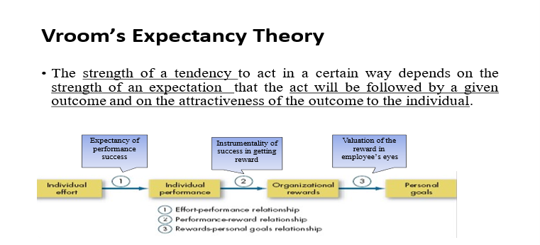

Adams’ Equity Theory
Employees compare their ratios of outcomes-to-inputs of relevant others.
When ratios are equal: state of equity exists – there is no tension as the situation is considered fair
When ratios are unequal: tension exists due to unfairness
Under-rewarded states cause anger
Over-rewarded states cause guilt
Tension motivates people to act to bring their situation into equity
Adams’ Equity Theory
TYPES OF EQUITY
    - EXTERNAL EQUITY – External equity denotes employee perception of fairness while comparing with the wages prevailing in external labour markets
    - INTERNAL EQUITY – Internal equity exists when the employees perceive that the wages are commensurate with the relative internal value of each job
    - INDIVIDUAL EQUITY – When individuals who on similar jobs are compensated on the basis of variations in individual performance, in so-called pay for performance, individual equity occurs
    - PERSONAL EQUITY – Personal equity involves no direct comparison between employees. It exists when the compensation that an employee receives, matches an employee's own image of his or her worth
    - PROCEDURAL EQUITY – It refers to the perceived fairness of the processes and procedures used to make decisions regarding the allocation of pay
Reactions to Inequity
Employee behaviors to create equity:
Change inputs (slack off)
Change outcomes (increase output)
Distort/change perceptions of self
Distort/change perceptions of others
Choose a different referent person
Leave the field (quit the job)
Propositions relating to inequitable pay:
Paid by time:
Overrewarded employees produce more
Underrewarded employees produce less with low quality
Paid by quality:
Overrewarded employees give higher quality
Underrewarded employees make more of low quality
Equity Theory’s “Relevant Others”
There can be four referent comparisons:
Self–Inside
The person’s experience in a different job in the same organization
Self–Outside
The person’s experience in a different job in a different organization
Other–Inside
Another individual or group within the organization
Other–Outside
Another individual or group outside of the organization
agency THEORY

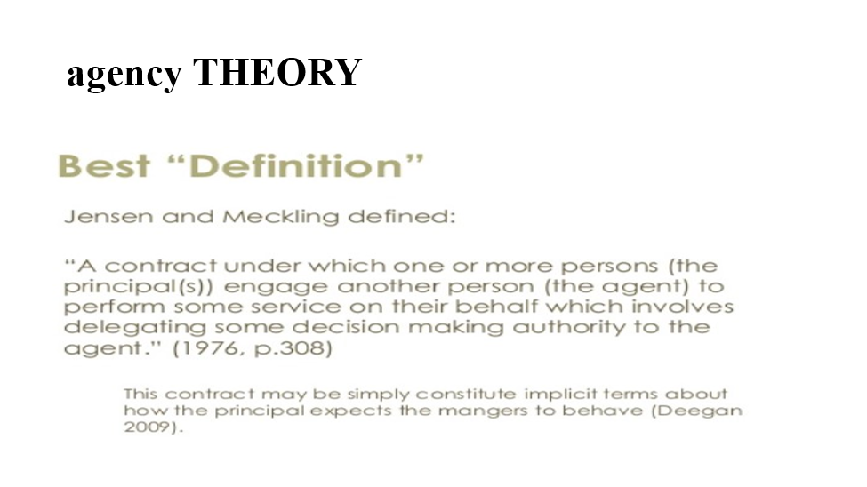

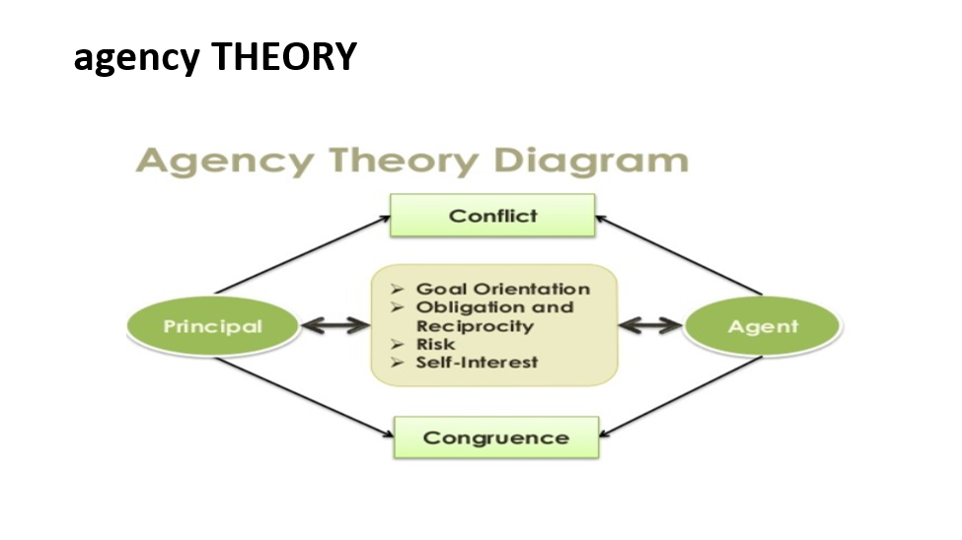

Factors influencing compensation

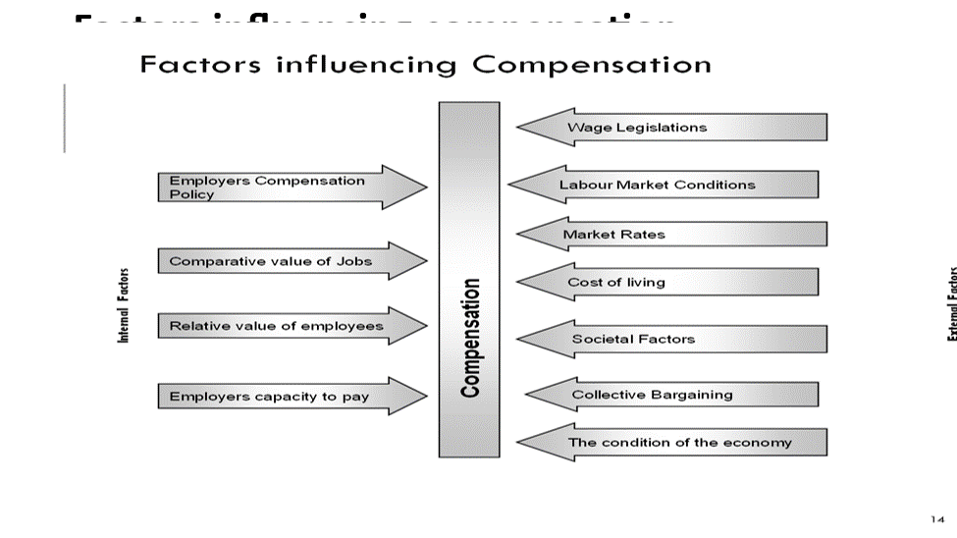

Establishing pay rates
There are several steps to designing a pay structure
- Collect and summarize work content information for each job through Job Analysis.
- Establish relative worth of different jobs through Job Evaluation.
- Gather Compensation data from other employers for comparable jobs through Salary survey.
- Formulate the Compensation policy in respect of external competitiveness.
- Integrate the internal structure (Step 2) with the external market pay rates and create a Compensation structure.
Employee Benefits
  - Employee Benefits (also covering fringe benefits, perquisites, or perks) constitute the indirect financial and non financial remuneration, which an employee is eligible to receive in addition to their normal wages or salaries, by virtue of being employed.
  - The objective of employee benefits is to address the economic security concerns of the employees, and while doing so, to improve employee retention in the organization.
Employee Benefits
Benefits include:
    - Housing accommodation
    - Accident insurance
    - Retirement benefits
    - Crèche
    - Scholarships
    - Educational assistance
    - Various kinds of leave
    - Leave Fare assistance
    - Social security
    - Profit sharing, and such specialized benefits
Components of Employee Benefits
- Employee benefits have two major components:
- Allowances
Allowances include Dearness Allowance, Compensatory allowances (City Compensatory, Hill allowance, duty allowance, Hardship allowance, Shift allowance, and Hazard allowance), Conveyance allowance, House Rent allowance, Deputation allowance, Education allowance etc.
2. Perquisites.
Perquisites include Leave Travel concession, Advances, Soft Furnishing reimbursements, Club membership, and Expense account etc.
Components of Employee Benefits - INDIA
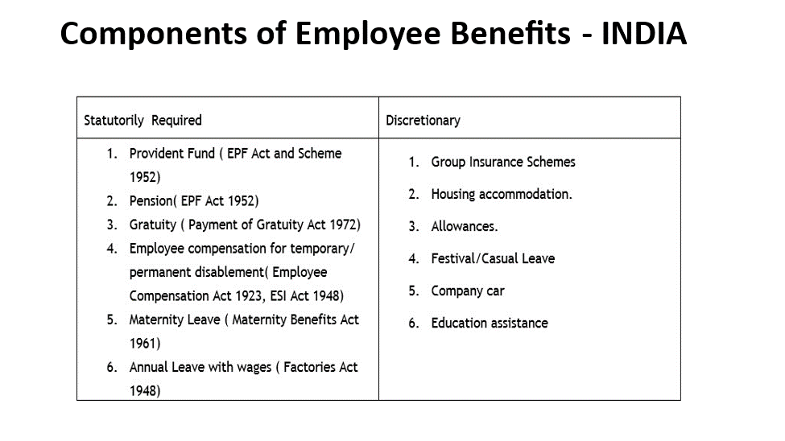
- Industrial Relations
- Decent Workplace
- People are gainfully employed (and there exist adequate income and employment opportunities);
- Social protection system (Labour protection and social security) is fully developed and accessible to all;
- Social dialogue and tri-partism are promoted and encouraged; and
- Rights at work, as specified in ILO Declaration on Fundamental principles and Rights at Work and Core ILO Conventions, are practiced, promoted and respected.
- International Labor Organisation,
- The concept of social dialogue covers all types of negotiation, consultation or exchange of information between or amongst representatives of governments, employers and workers on issues of common interest relating to economic and social policy. The underlying principle of social dialogue is that “management by agreement is preferable to management by Diktat. Negotiation is more democratic than unilateral imposition. Hence collective bargaining and social dialogue are the most appropriate means of regulating employment relations, a principle which has been widely reasserted in the current crisis”.
- ILO Working Paper No 11. 2010)
- Industrial Relations
- According to Encyclopedia Britannica, industrial relations denote “the relations of the state with employers, workers, and other organizations. The subject, therefore, includes individual relations and joint consultation between employers and workers at their places of work, collective relations between employers and trade unions; and the part played by the State in regulating these relations”.
- Dale Yoder (Personnel Management and Industrial Relations. Prentice Hall. 1942) considers IR to be “a designation of a whole field of relationship that exists because of the necessary collaboration of men and women in the employment processes of Industry”.
- According to Armstrong Ir is “concerned with the systems and procedures used by unions and employers to determine the reward for effort and other conditions of employment, to protect the interests of the employed and their employers and to regulate the ways in which employers treat their employees”(Human Resource Management. Kogan Page)
- Objectives of industrial relations
- No. of Strikes & lockouts and their intensity - man days / man-hours lost & production loss during last five years.
- Productivity improvement initiatives and result achieved.
- Welfare measures and CSR activities launched by the company.
- Training/re-training and skill development initiatives taken by the company for employee's development.
- Number of Industrial Disputes pending.
- Information about grievance machinery set up by the management at various levels for redressal of genuine grievances of workers.
- Whether Works Committees have been set up: if so, details about their composition, functioning and settlement of issues referred to it.
- Voluntary welfare measures initiated by the company.
- Whether the company has initiated steps towards involving workers' in various decision making process.
- Formal as well as informal forums & number of committees.
- The system of communication adopted with employees & its relevance in the industrial relations.
- Employee retention rate during the last 5 years.
- Approaches to industrial relations
- Unitarist approach
- Systems approach
- Oxford approach
- Sociology approach.
- Marxist approach
- Pluralist approach
- Gandhian Approach
- Strategic Choice Model.
- The role of government in industrial relations
- The decline of trade unions
- In line with a global trend, researchers found a drop in the number of unions submitting annual "returns" to the central government.
- In West Bengal, for example, during the period 1982-90 prior to liberalization , 4,380 new unions with a total membership of 629,151 were registered; but in the subsequent nine years post liberalisation, , the number shrank to 2,686 with 240,624 new members .
- Regarding the causes for the decline, there is a view that innovative HRM practices pose a threat to trade unions in four ways;
  - The individualization of employment contract,
  - The demise of union representation,
  - The intensification of work and
  - Undermining of union solidarity through organizational commitment ..
- HRM with union consent
- Bluestone and Bluestone has suggested a three track system to classify the different kinds of union- HRM interface existing in different organizations.
- Track 1 captures the traditional combative relations over common workplace issues;
- Track 2 describes participation of the individual employees in such workplace decision making activities.
- Track 3 there is a direct union involvement in a number of issues. According to Blackstone, the Track 3 model compels the union to adopt joint responsibility for quality and partnership, and thereby its adversarial role gets seriously undermined.
- Indian scene: Coexistence of IR and HRM?
- The tightly drawn frontiers between HRM and IR needs to melt and IR thinking would need to change to become strategic. Two-way communication, training and motivation of individual employees are irreversible processes.
- But the bottleneck appears to be in workplace flexibility (functional, working time, types of contracts, workforce size), job design and pay systems, where traditional IR and HRM are bound to lock horns.

